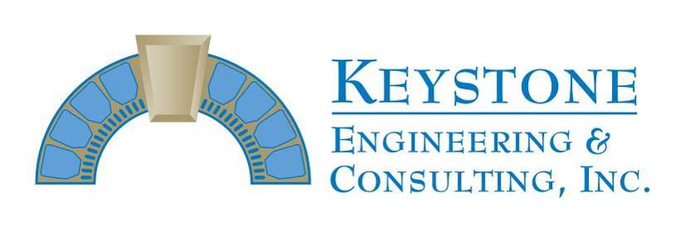
166 Center Street Suite #21o
Cape Canaveral, FL 32920
Phone: 321-454-7300
Fax: 321-459-2888
Progress Inspection Report #142
Permit # 20BC08596

Project Name: East Horizon Progress Report thru 12-4-20
Project Address: 401 Highway A1A, Satellite Inspection Visits: 11-30 thru 12-3

Prime Contractor: Chematics
Superintendent: Jim Sweet

Activities in-progress: building 4 – 3rd floor balcony PT cable re-tensioning, lock-off removal, sheathing install and lock-off formwork/casting; 1st floor balcony east-west PT lock-offs, slab edge demo and reinforcing steel; 3rd floor balcony initial flood testing/surface profiling; walkway deck coating removal

INSPECTORS REPORT

Keystone Engineering visited the site on 11-30 thru 12-3 and also had several conversations with the construction team by telephone throughout the week.

Initial post tension cable re-tensioning was completed Wednesday on the 3rd floor balconies. After re-tensioning, lock-offs were removed and sheathing was installed on exposed cable and splice chucks. Cable ends were cut in preparation for grease cap installations and formwork/casting of lock-off excavations was in-progress Thursday and Friday on the 3rd floor balconies. Multiple east-west post tension cables broke during re-tensioning on the 3rd floor balconies and necessary repairs where cables cannot be abandoned are scheduled to begin next week.

East-west post tension cable lock-off installations remain in-progress on the 1st floor balconies, finished on Units 411/412 and wrapping up on Units 413/414. Slab edge/full depth excavations and reinforcing steel placement also remain in-progress on 1st floor balconies where post tension cables have been locked-off, scheduled to continue next Monday.

Deck coating removal was finished on the 1st and 2nd floor walkways in order to begin marking out areas for repair. Initial flood testing/surface profiling is in-progress on 3rd floor balconies and stucco finish application remains in-progress over repaired areas.

James E. Emory, P.E.

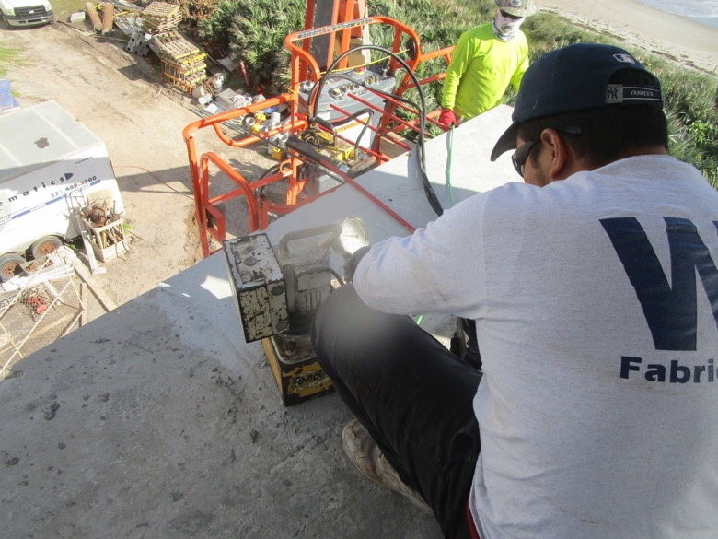
View of north-south PT cable re-tensioning in-progress on the Unit 431 balcony

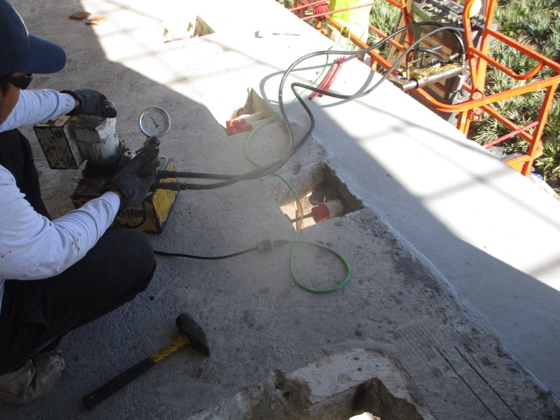
View of east-west PT cable re-tensioning in-progress on the Unit 431 balcony

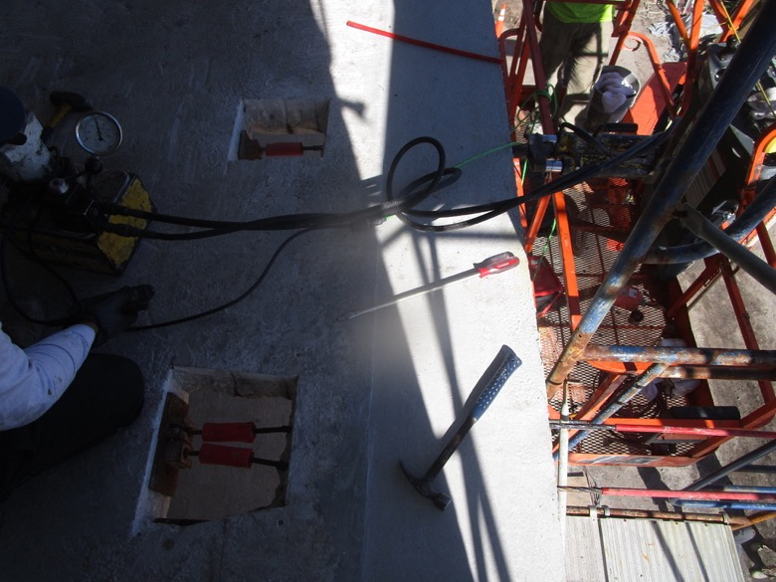
Additional view of east-west PT cable re-tensioning in-progress on the Unit 431 balcony

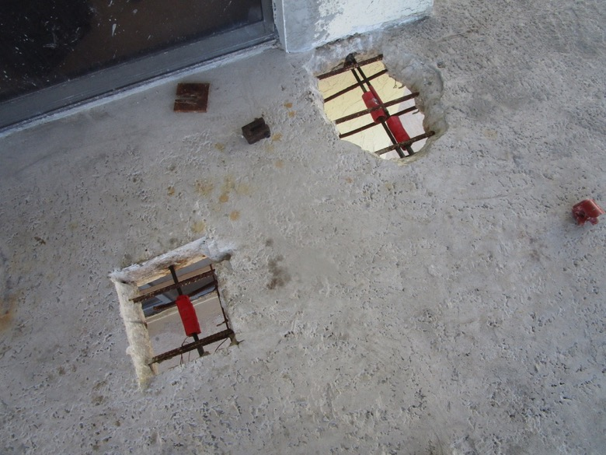
View showing east-west PT cables re-tensioned with lock-offs removed on the Unit 431 balcony

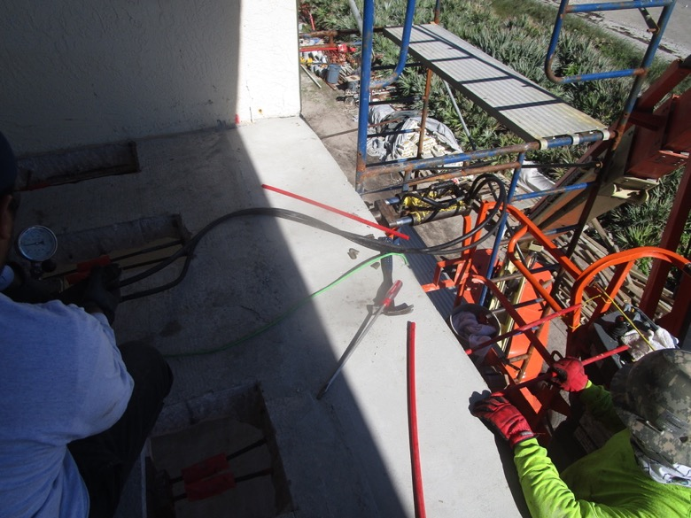
View of east-west PT cable re-tensioning in-progress on the Unit 432 balcony

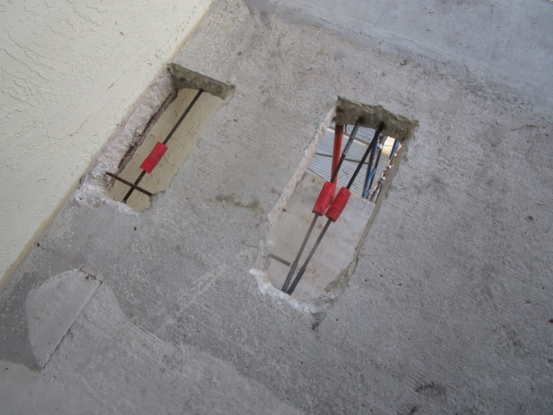
View showing east-west PT cables re-tensioned with lock-offs removed on the Unit 432 balcony

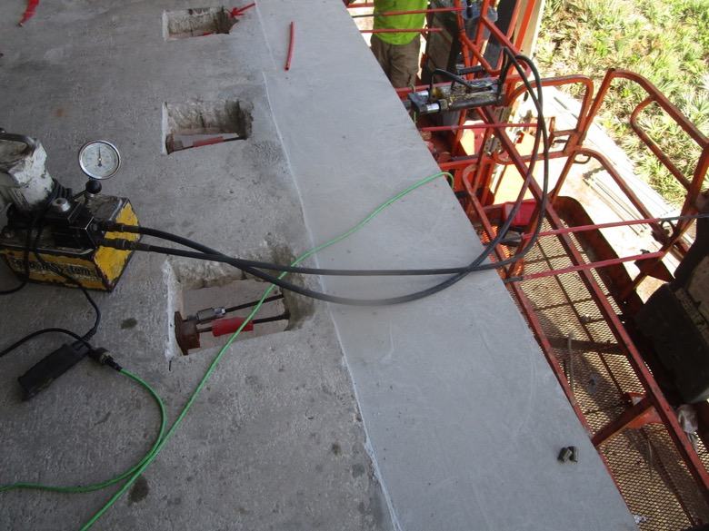
View of east-west PT cable re-tensioning in-progress on the Unit 433 balcony

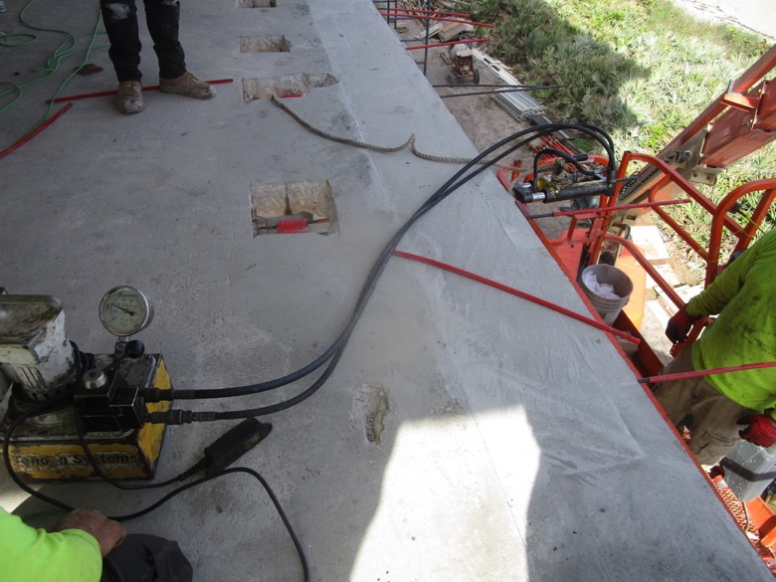
View of east-west PT cable re-tensioning in-progress on the Unit 434 balcony

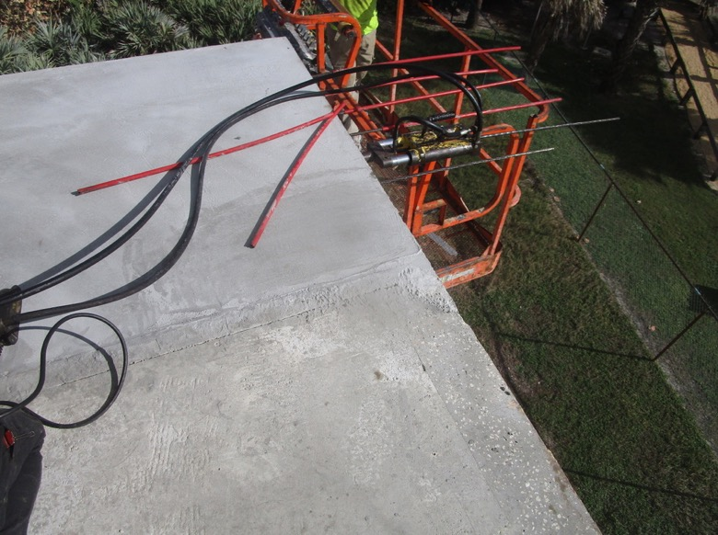
View of north-south PT cable re-tensioning in-progress on the Unit 434 balcony

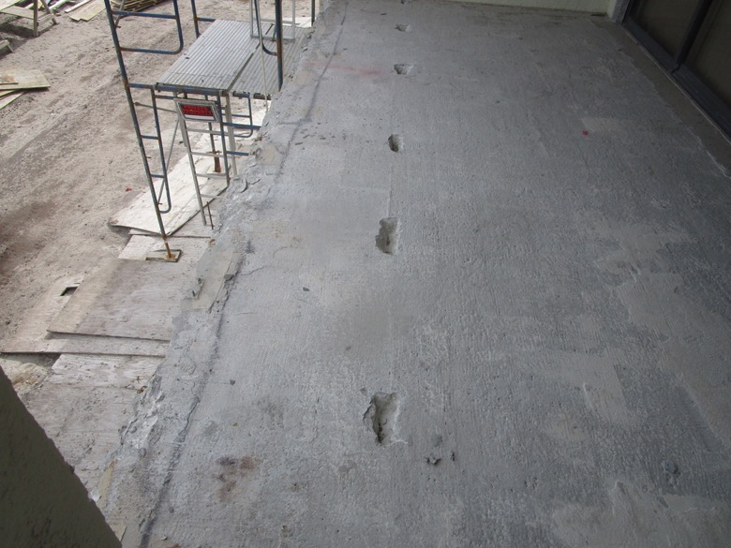
View of east-west PT cable locating in-progress on the Unit 413 balcony

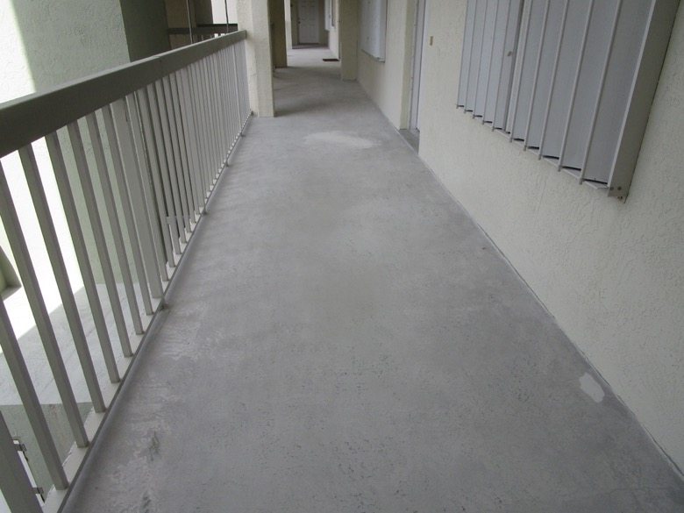
View of deck coating removed on the 2nd floor walkway

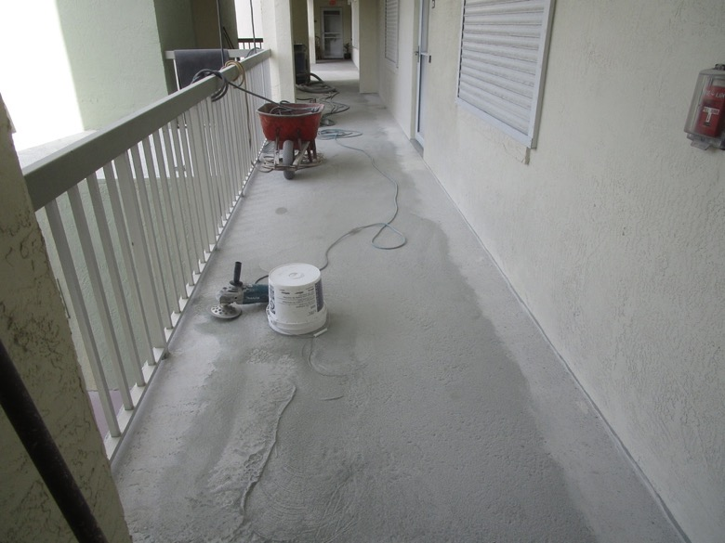
View of deck coating removal in-progress on the 1st floor walkway

