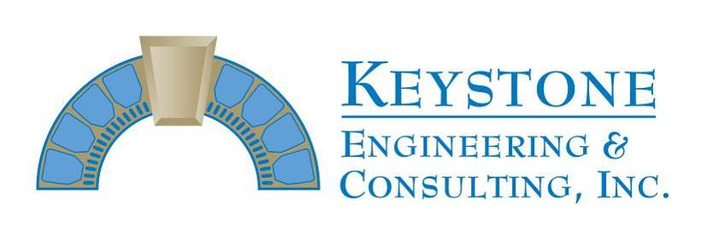
166 Center Street Suite #21o
Cape Canaveral, FL 32920
Phone: 321-454-7300
Fax: 321-459-2888
Progress Inspection Report #76
Permit # 18BC03039

Project Name: East Horizon Progress Report thru 8-30-19
Project Address: 401 Highway A1A, Satellite Inspection Visits: 8-28 thru 8-30

Prime Contractor: Chematics
Superintendent: Jim Sweet

Activities in-progress: building 3 – 2nd floor balcony column form removal; 3rd floor balcony column stucco removal and excavations; 3rd floor balcony east-west PT lock-offs and Unit 331, 332, and 333 slab edge/full depth demo; building 2 balcony deck coatings, north and south shearwall coatings; storm prep

INSPECTORS REPORT

Keystone Engineering visited the site on 8-28 thru 8-30 and also had several conversations with the construction team by telephone throughout the week.

All 2nd floor balcony column repairs have been cast back and formwork was removed in preparation for stucco finish. Delaminated stucco removal and minor column excavations remain in-progress on 3rd floor balconies, scheduled to continue next week.

On the Unit 331, 332 and 333 balconies, east-west post tension cable lock-offs were installed and slab edge/full depth excavations were in-progress throughout the week. East-west post tension cable lock-off installations were in-progress Friday on the Unit 334 balcony with slab edge excavations scheduled to continue next week.

On the building 2 balconies, deck coatings have been applied and surface preparation was finished on the north and south elevation shearwall window drops. Wall coatings were wrapping up Thursday on the building 2 north and south elevation shearwalls. Storm preparation for hurricane Dorian was in-progress Wednesday, Thursday, Friday and throughout the weekend on buildings 2 and 3 with sliding glass doors boarded up using ¾” plywood, removed handrails secured to balcony decks, materials/tools stowed in onsite storage containers and exposed scaffold/equipment secured.

James E. Emory, P.E.

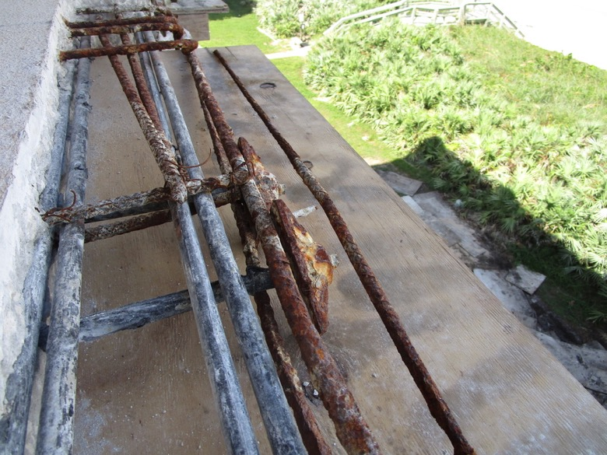
View of severely corroded PT anchor heads and reinforcing steel exposed on the Unit 331 balcony east elevation

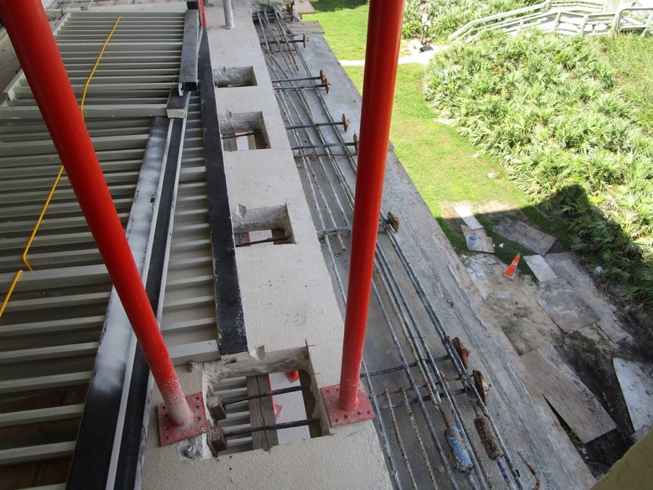
View of east-west PT cables locked-off with slab edge demo wrapping up on the Unit 331 balcony east elevation north end

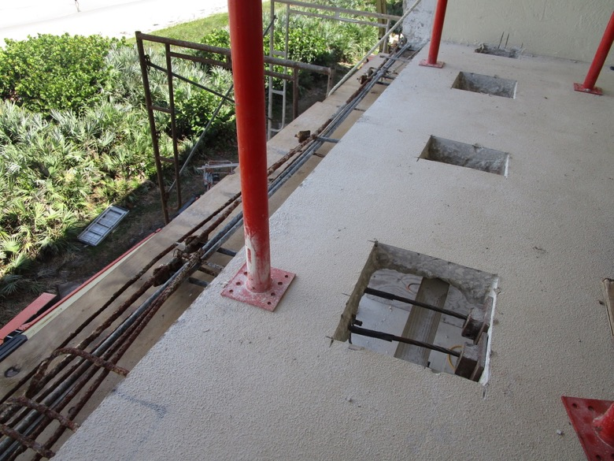
View of east-west PT cables locked-off with slab edge demo wrapping up on the Unit 331 balcony east elevation south end

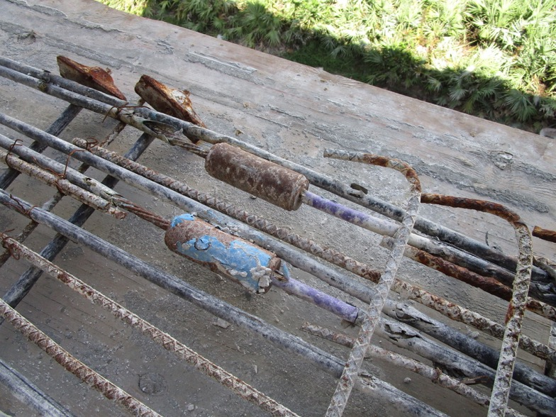
View of splice chucks exposed from a previous repair that will be removed/replaced on the Unit 331 north-south PT cables

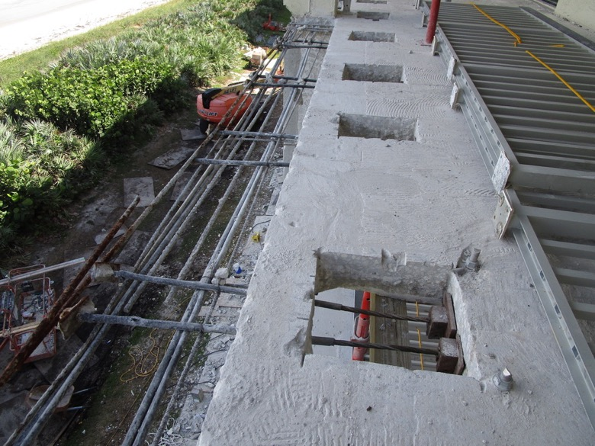
View of east-west PT cables locked-off with slab edge demo wrapping up on the Unit 332 balcony north end

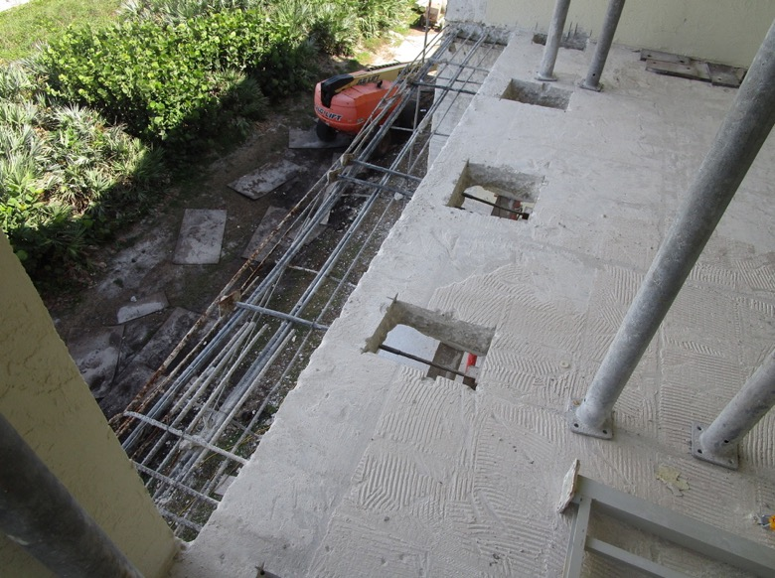
View of east-west PT cables locked-off with slab edge demo wrapping up on the Unit 332 balcony south end

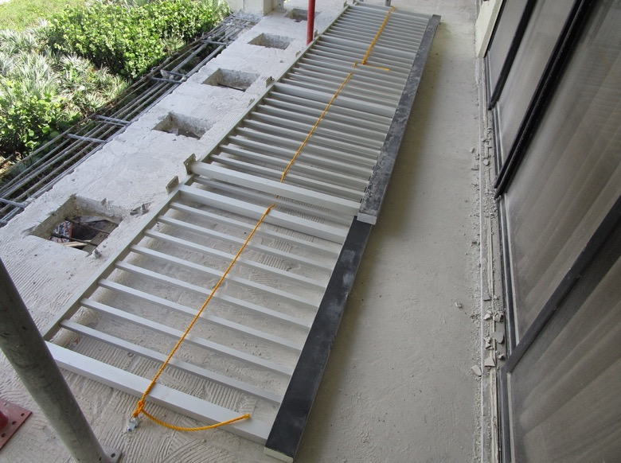
View of handrails being secured for storm preparation on the Unit 332 balcony

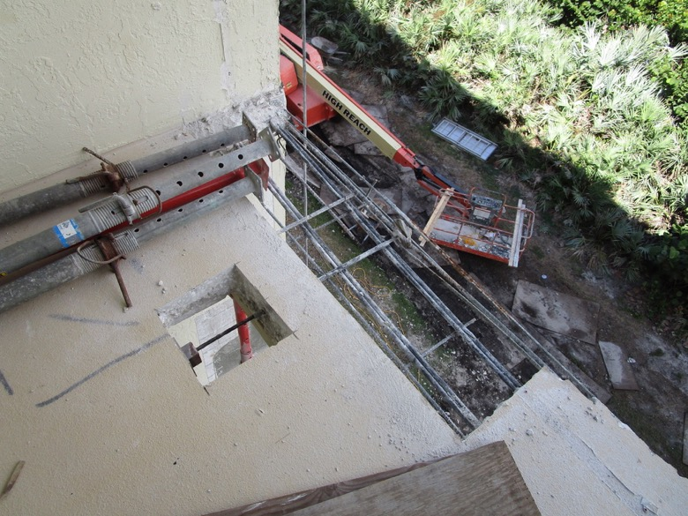
View of east-west PT cable locked-off with slab edge demo wrapping up on the Unit 333 balcony north end

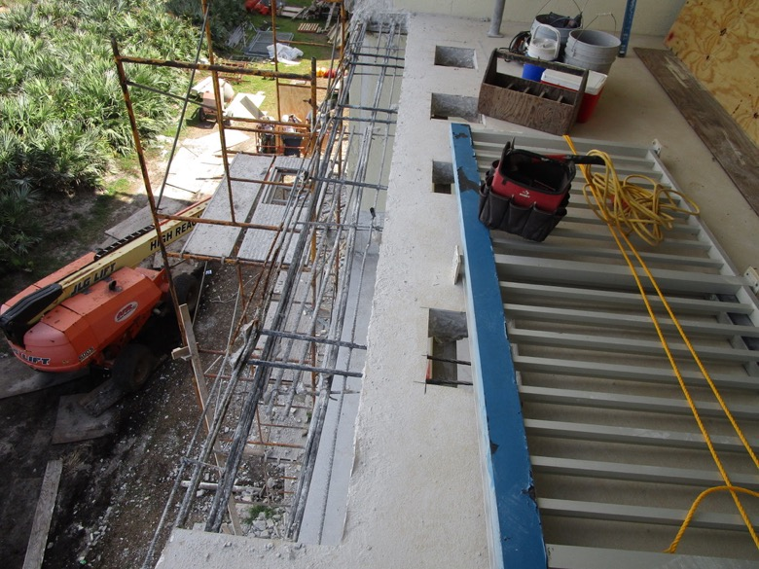
View of east-west PT cables locked-off with slab edge demo wrapping up on the Unit 333 balcony south end

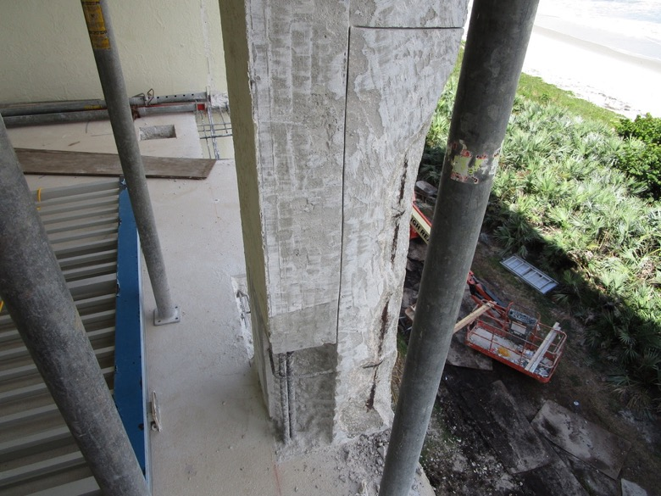
View of column excavations in-progress on the Unit 333 balcony

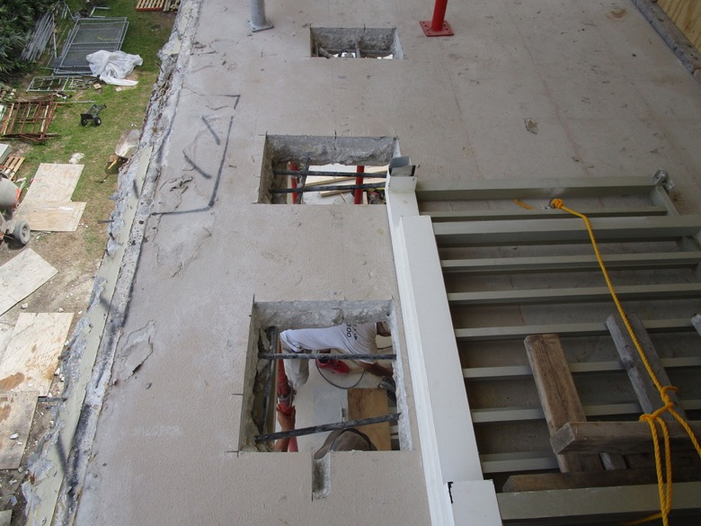
View of full depth excavations completed at east-west PT cable locations on the Unit 334 balcony prior to lock-off installations

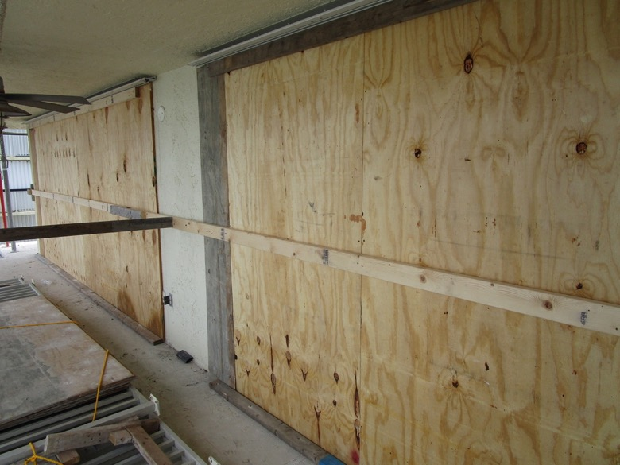
View of SGDs boarded up on the Unit 334 balcony

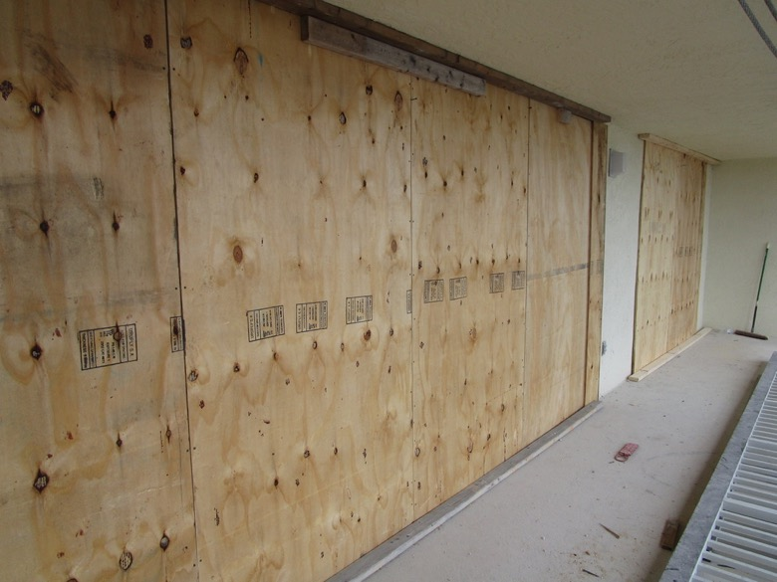
View of SGDs boarded up on the Unit 313 balcony

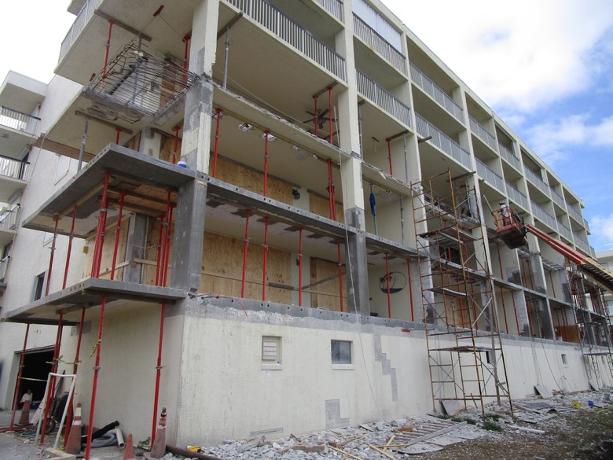
View of work to date with storm preparation in-progress on the building 3 balconies

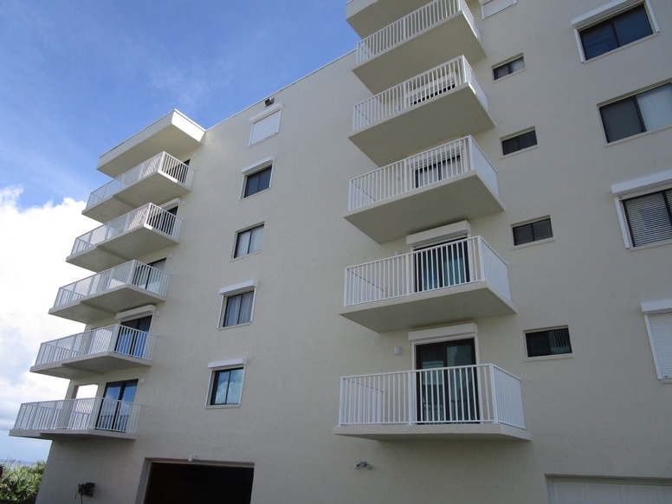
View of coatings applied on the building 2 north elevation shearwall

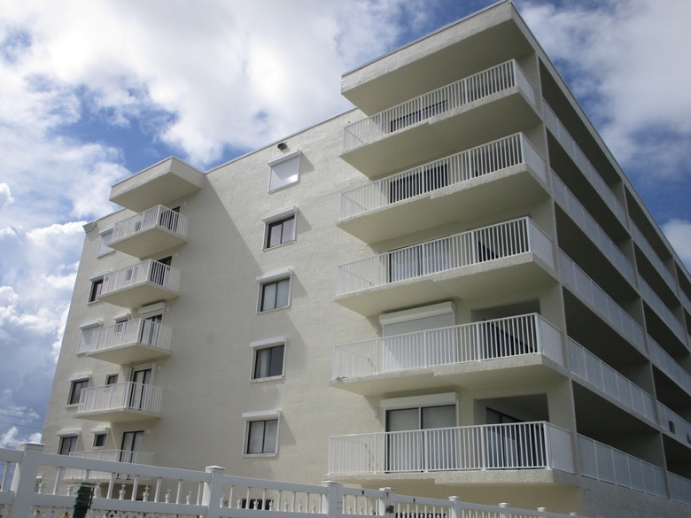
View of coatings applied on the building 2 south elevation shearwall

