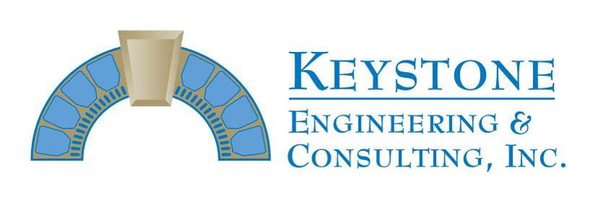
166 Center Street Suite #21o
Cape Canaveral, FL 32920
Phone: 321-454-7300
Fax: 321-459-2888
Progress Inspection Report #79
Permit # 18BC03039

Project Name: East Horizon Progress Report thru 9-20-19
Project Address: 401 Highway A1A, Satellite Inspection Visits: 9-16 thru 9-20

Prime Contractor: Chematics
Superintendent: Jim Sweet

Activities in-progress: building 3 – 3rd floor balcony reinforcing steel placement, formwork, detailing, pre-pour and casting; Unit 331 and 334 kitchen balcony mark out; 3rd floor balcony column excavations; building 2 – walkway wall/ceiling and deck coatings, handrail coatings

INSPECTORS REPORT

Keystone Engineering visited the site on 9-16 thru 9-20 and also had several conversations with the construction team by telephone throughout the week.

A final pre-pour inspection was completed Wednesday on the Unit 331, 332, 333 and 334 east elevation balconies. Existing reinforcing steel was detailed and minor adjustments to bursting bar steel and post tension anchor heads were finished Wednesday afternoon. Final form construction was finished and the 3rd floor east elevation balcony repairs were cast back on Thursday.

Areas were marked for repair on the Unit 331 and 334 kitchen balconies on Monday and excavations are scheduled to begin next week. Initial column excavations are nearing completion on the 3rd floor east elevation balconies and a pre-pour inspection is scheduled for next Thursday in order to begin detailing existing steel and constructing forms. Post tension cable re-tensioning on 3rd floor balconies is scheduled for next Thursday.

On building 2, priming/painting on walkway walls/ceilings was finished and deck coatings were wrapping up Friday. Stairwell handrail painting was also completed on the walkways and final touch up work is scheduled for completion early next week.

James E. Emory, P.E.

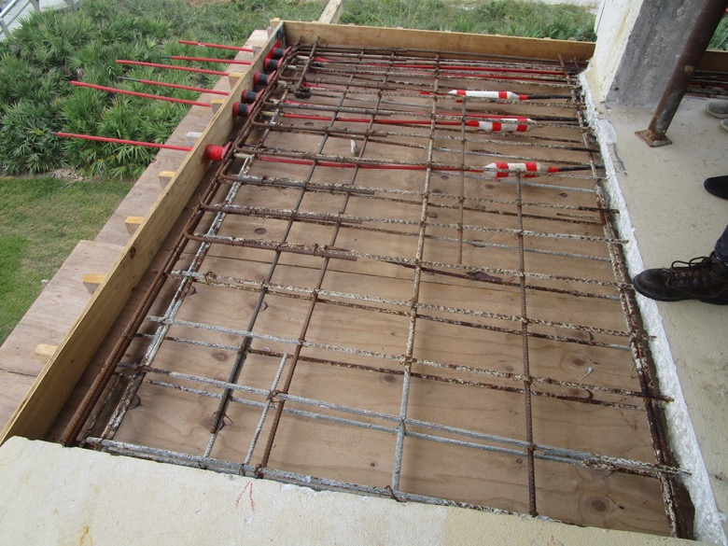
View of forms constructed with reinforcing steel set prior to final detailing on the Unit 331 balcony northeast corner

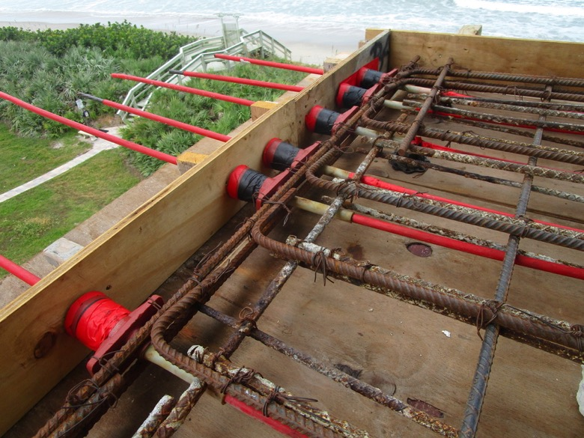
View showing north-south PT anchor heads tied into bursting bar reinforcing steel on the Unit 331 balcony northeast corner

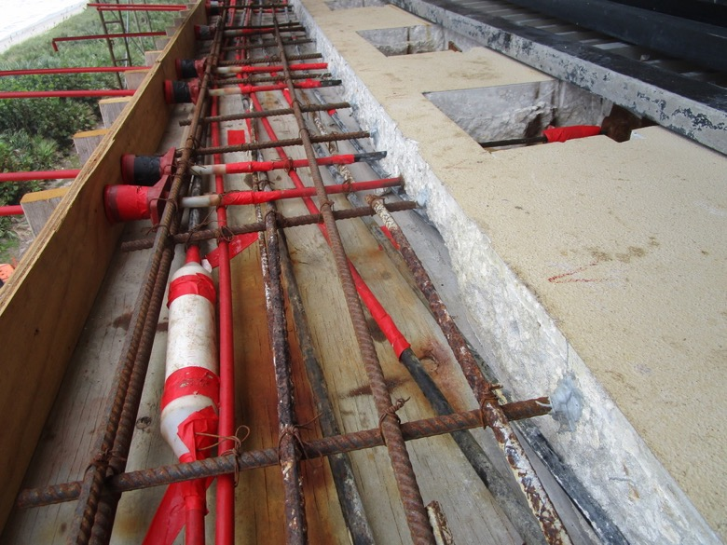
View of PT anchors and reinforcing steel set with forms constructed on the Unit 331 balcony east elevation slab edge north side

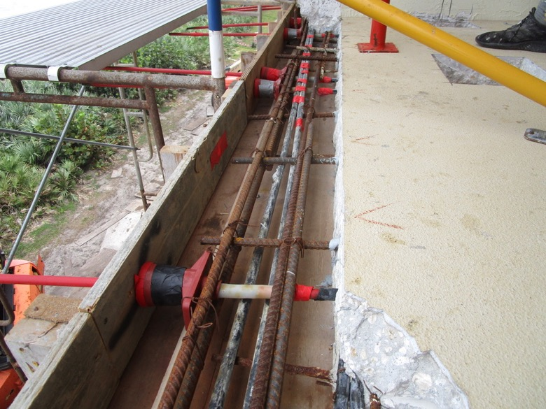
View of PT anchors and reinforcing steel set with forms constructed on the Unit 331 balcony east elevation slab edge south side

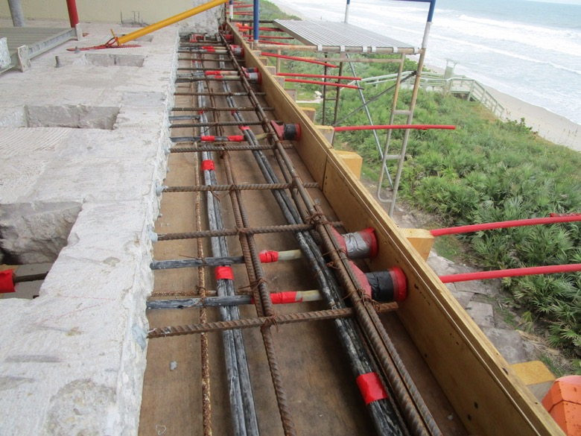
View of PT anchors and reinforcing steel set with forms constructed on the Unit 332 balcony slab edge north side

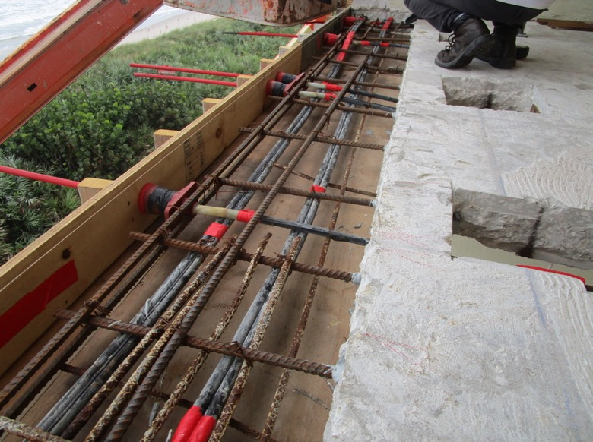
View of PT anchors and reinforcing steel set with forms constructed on the Unit 332 balcony slab edge south side

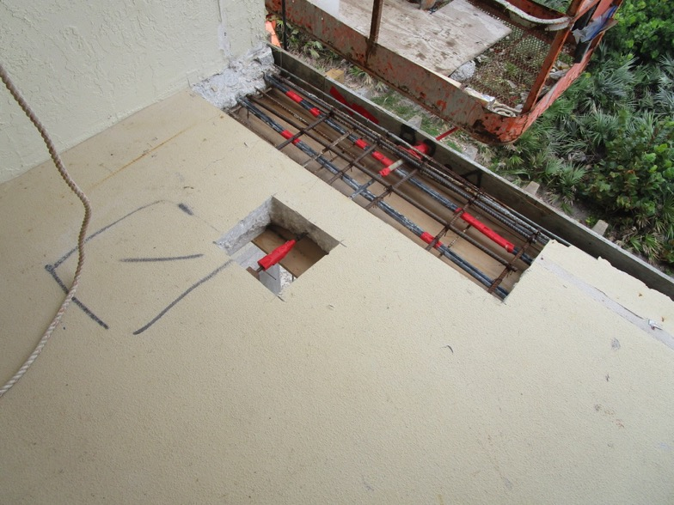
View of PT anchors and reinforcing steel set with forms constructed on the Unit 333 balcony slab edge north side

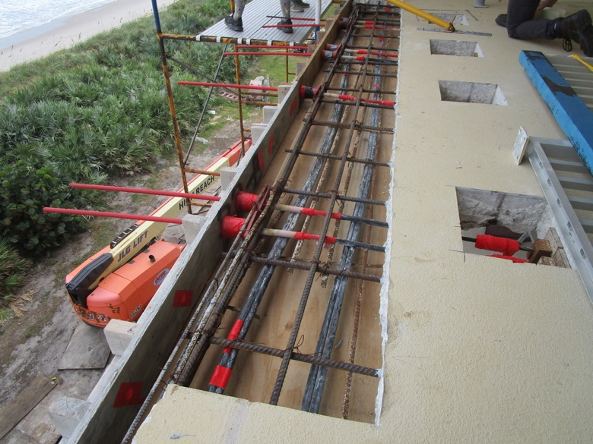
View of PT anchors and reinforcing steel set with forms constructed on the Unit 333 balcony slab edge south side

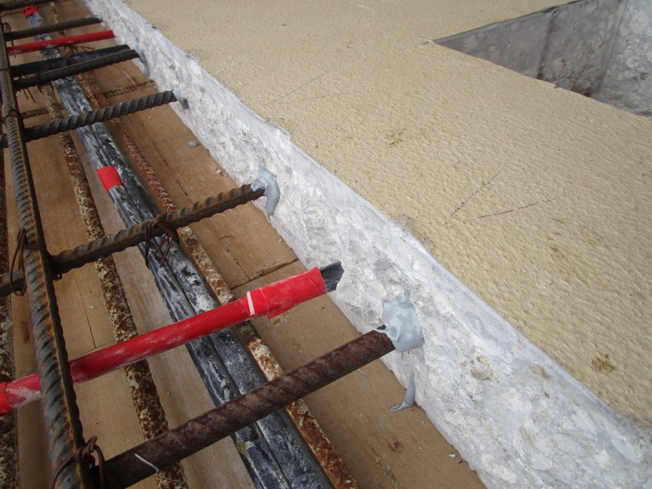
View showing #5 rebar doweled-in/epoxy set on the Unit 333 balcony slab edge repair

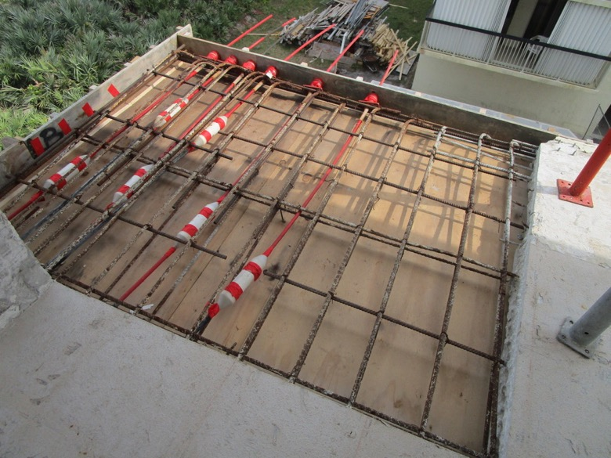
View of forms constructed with reinforcing steel set prior to final detailing on the Unit 334 balcony southeast corner

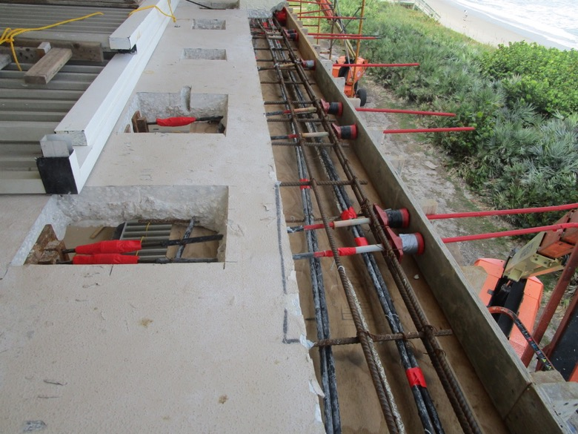
View of PT anchors and reinforcing steel set with forms constructed on the Unit 334 balcony east elevation slab edge south side

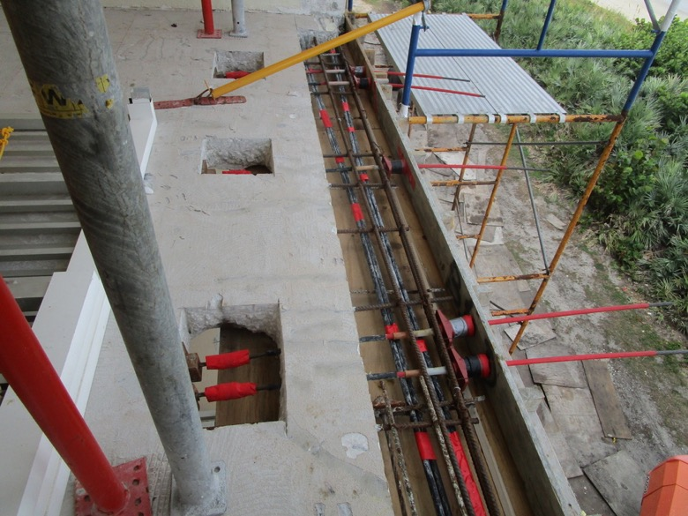
View of PT anchors and reinforcing steel set with forms constructed on the Unit 334 balcony east elevation slab edge north side

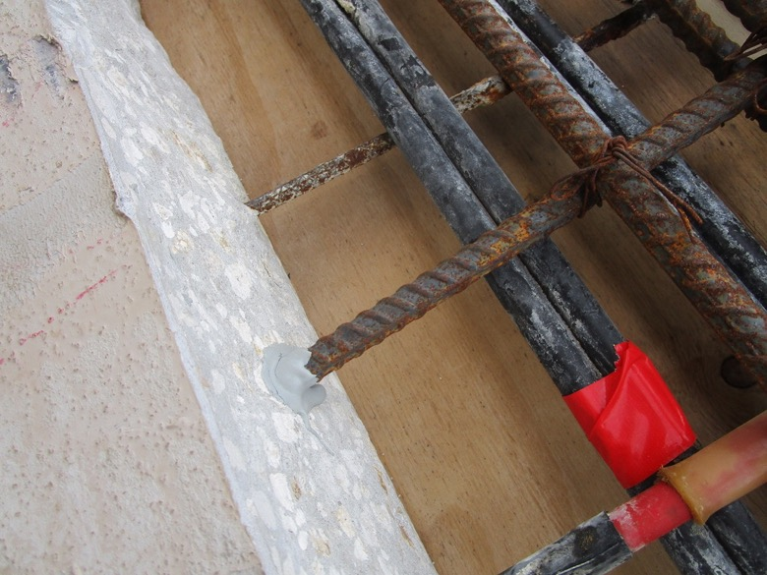
View of showing #5 rebar doweled-in/epoxy set on the Unit 334 balcony

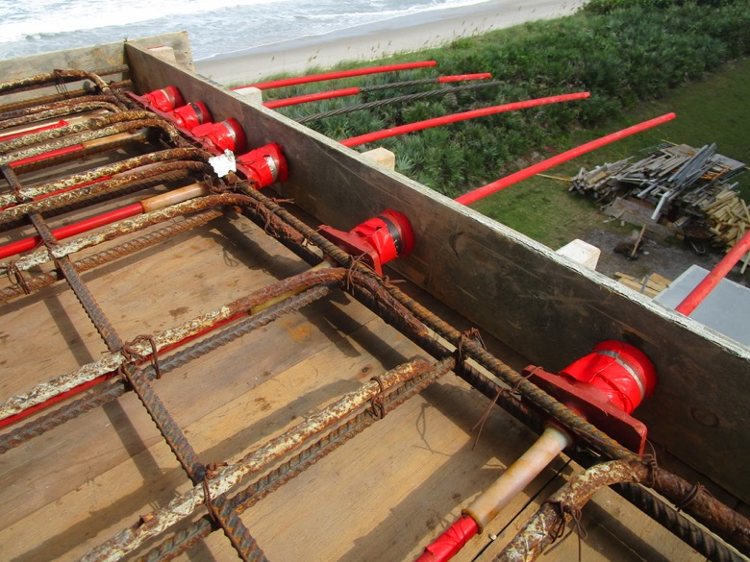
View showing north-south PT anchor heads tied into bursting bar reinforcing steel on the Unit 334 balcony southeast corner

